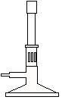
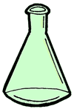
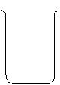
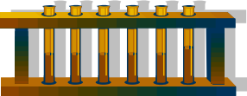

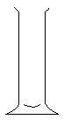
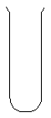
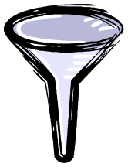

Tripod

Gauze mat

Bunsen board

Test-tube

Tongs

Test-tube holder

Stirring rod

